**Module – 3**

**Socket Programming**

**Experiment – 1**

**To find the website address using socket programming**

**Code :**

**import** java.util.*;

**import** java.net.*;

**public** **class** IPFinder {

**public** **static** **void** main(String[] args) {

// **TODO** Auto-generated method stub

String host;

Scanner input = **new** Scanner(System.***in***);

System.***out***.println("Enter Host Name : ");

host = input.next();

**try** {

InetAddress address = InetAddress.*getByName*(host);

System.***out***.println("IP address: " + address.toString());

}

**catch** (UnknownHostException uhEx)

{

System.***out***.println("Could not find " + host);

}

}

}

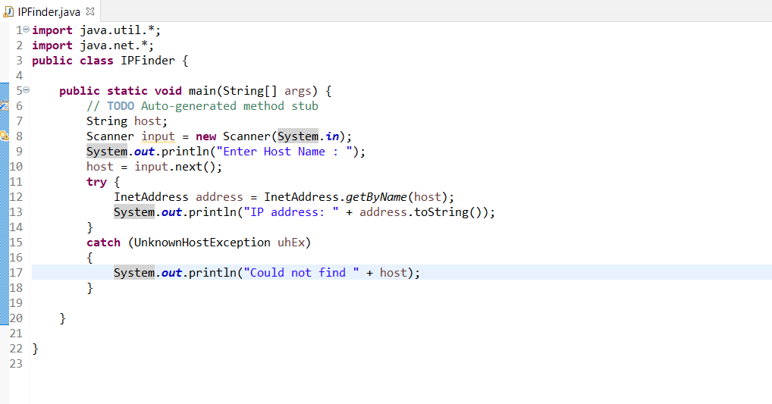

**Output:**

